Machine Learning Simplified Series
Part 1: Unsupervised Learning (Clustering ) Your First Step into Machine Learning

1. What Is Machine Learning?
Machine Learning is a way of teaching computers to learn patterns from data instead of explicitly programming rules (like an if else logic).
To put in simple terms, In traditional programming, we write rules like an if else logic and apply them to data to get outputs.
In machine learning, we pass the data directly to the computer and let it learn the rules and patterns on its own.
If data has patterns, machine learning finds them automatically, we just feed data to the machine.

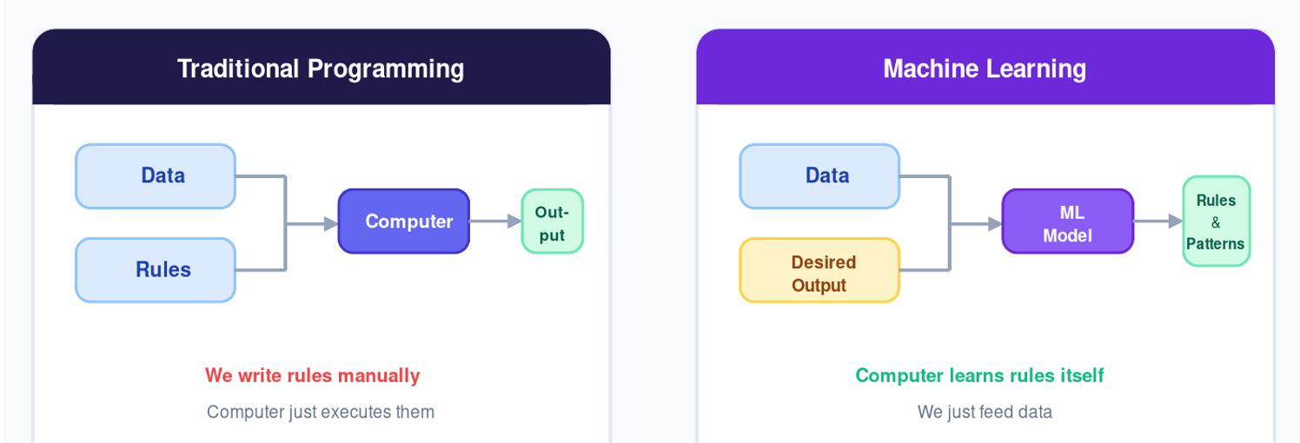

In Simple Terms: In traditional programming, we write the rules manually. In machine learning, the computer learns the rules itself from the data. No manual programming of logic required.

2. Why Do We Need Machine Learning?
In today’s world, data is everywhere and growing exponentially than humans can process it:

- Millions of customers (e.g. Amazon has millions of customers)
- Billions of transactions (e.g. Walmart processes billions of dollars in transactions)
- Huge amounts of images, text, and logs generated every day

Manually analysing such huge data is impossible. Machine learning helps by:
- Identifying patterns humans can’t easily see
- Automating decision-making
- Scaling analysis to massive datasets

Real-World ML Applications
- Customer segmentation and personalisation
- Recommendation systems (Netflix, Amazon, YouTube)
- Fraud detection
- Spam detection
- Medical diagnosis
- Demand forecasting

3. Two Types of Machine Learning
Depending on whether your data has labels or not, Machine Learning can be broadly classified into two categories:

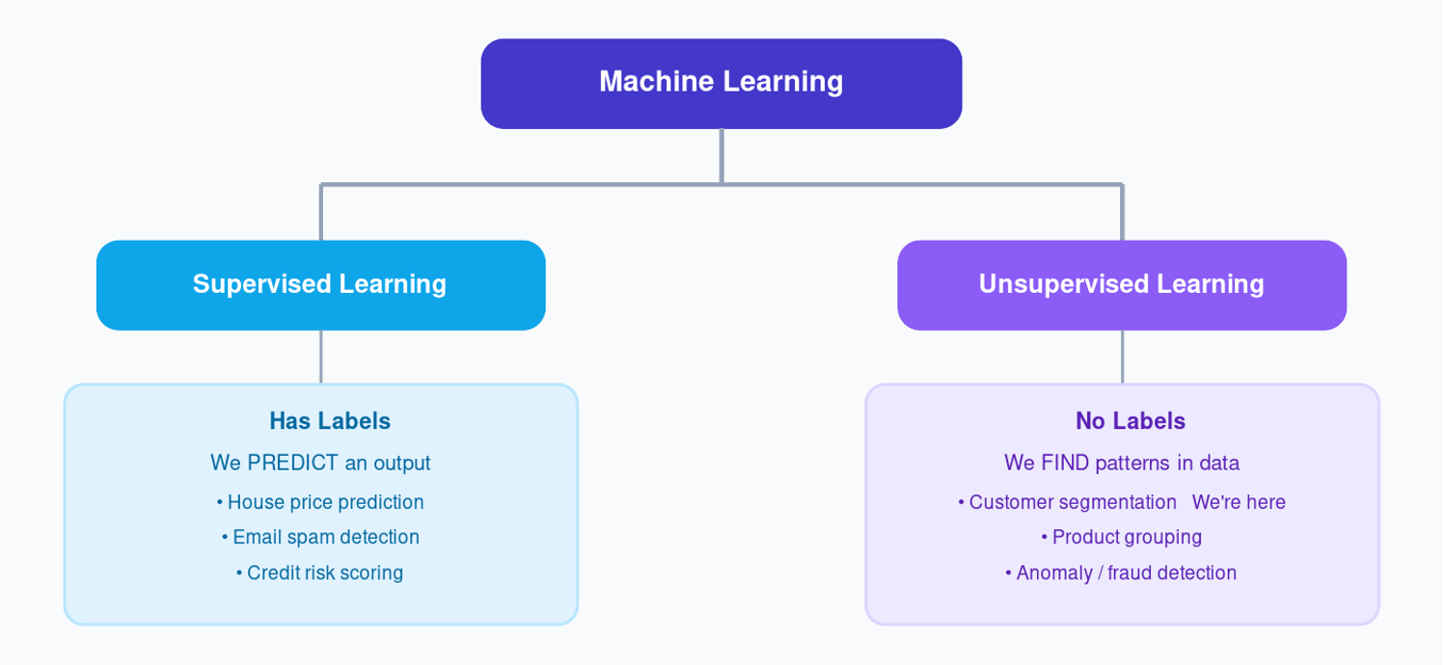

Supervised Learning  Data has known labels/answers. We want to predict an output. Examples: house price prediction, email spam detection, credit risk. | Unsupervised Learning  No labels provided. We are NOT predicting — just finding patterns. Examples: customer segmentation, product grouping, anomaly detection.

Where Clustering Fits: Clustering falls under Unsupervised Learning. We are not trying to predict any output as we are simply trying to create segments and groups in the data.

4. What Is Clustering?
Clustering is an unsupervised learning technique where the objective is to group similar data points together without any predefined labels. The algorithm looks only at the features of the data and discovers natural groupings.

“The algorithm will try to create different groups in your data and will allocate every single data point to one group or another.”

Let’s imagine a business that has thousands of customers (like Walmart or Nature Basket). Customers from different age groups, different income levels and different spending behaviours do shopping in these stores.
Clustering helps the business identify groups such as low-income low-spenders, high-income high-spenders, etc., and design different marketing strategies for each group.

Real-World Use Cases
Customer Segmentation  Group customers by age, income, and spending habits to design targeted marketing strategies. | Recommendation Systems  Netflix and Amazon cluster users with similar preferences to recommend products or movies.

5. How Does Clustering Decide Groups?

“The entire clustering algorithm works on the notion of similarity and dissimilarity.”

There are two ways to measure similarity between data points and help group them:

Distance-Based Metrics  Measures how far apart two points are.  • Euclidean Distance  • Manhattan Distance  • Minkowski Distance | Similarity-Based Metrics  Measures how alike two points are.  • Cosine Similarity  • Jaccard Index

This blog and the next one we will be focusing on Distance Based Metrics followed by Similarity Based Metrics in future blogs.
The most widely used metric is Euclidean Distance. Let’s understand it with a worked example.

6. Our Sample Dataset
Let’s work with four customers represented by two features: Age and Monthly Income.
We can plot them on a 2D graph i.e. Age on the X-axis, Income on the Y-axis.

Customer | Age (years) | Monthly Income (₹) | Plot Position
A | 20 | 1,000 | (20, 1000)
B | 30 | 1,200 | (30, 1200)
C | 70 | 1,100 | (70, 1100)
D | 50 | 5,000 | (50, 5000)

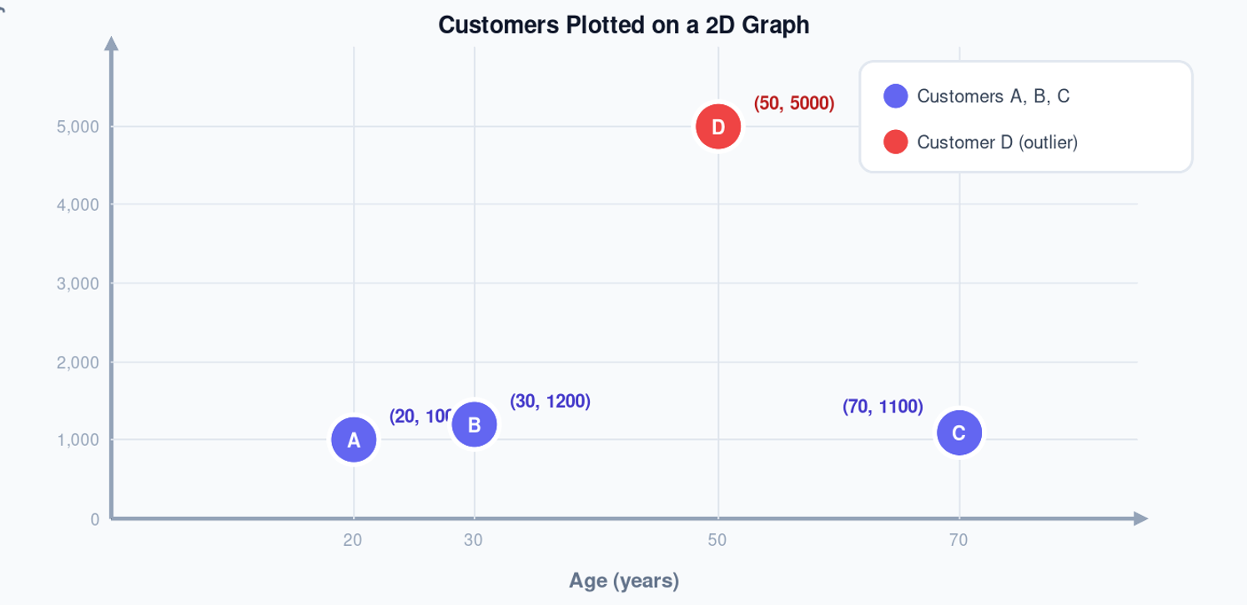
If we look at the above graph we can sense that A,B,C are somewhat closer to each other as compared to D which seems very far from these data points.
So, we can say that we can create two clusters: Cluster1 (with three data points A,B,C) and Cluster2 (with one data point D)

Layman Intuition: Think of each customer as a dot on a graph. Customers that are physically closer are considered more similar. Smaller Distance = More Similar. Larger Distance = Less Similar.

7. Euclidean Distance - The Math Behind it
To determine which customers are similar, we calculate the straight-line distance between every pair of points.

Distance = √[ (x₂ − x₁)² + (y₂ − y₁)² ]

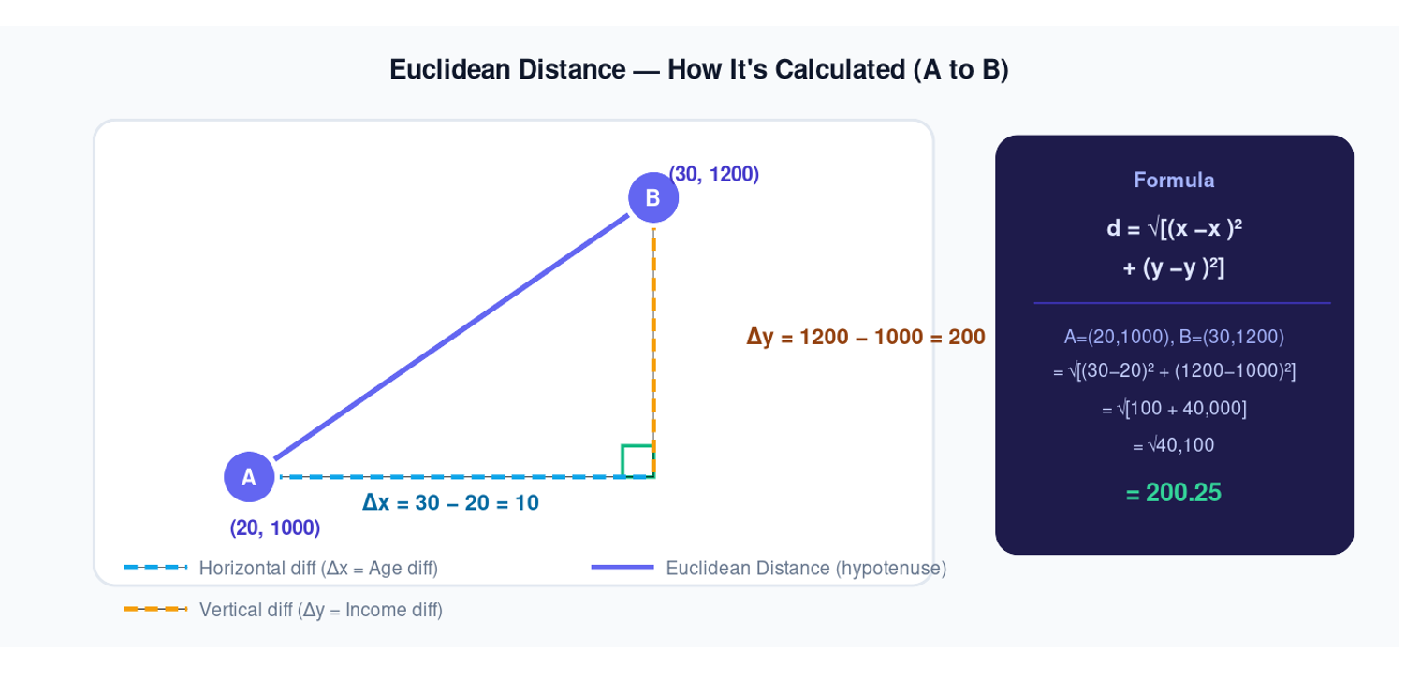

All Pairwise Distance Calculations

Pair | Calculation | Distance | Similarity
A – B | √[(30−20)² + (1200−1000)²] = √40,100 | 200.25 | Close
A – C | √[(70−20)² + (1100−1000)²] = √12,500 | 111.80 | Close
B – C | √[(70−30)² + (1100−1200)²] = √11,600 | 107.70 | Closest
A – D | √[(50−20)² + (5000−1000)²] = √16,000,900 | 4,000.10 | Far
B – D | √[(50−30)² + (5000−1200)²] = √14,440,400 | 3,800.10 | Far
C – D | √[(50−70)² + (5000−1100)²] = √15,210,400 | 3,900.00 | Far

8. Forming the Clusters
Based on the distances, the pattern is clear: A, B, and C are all within 100–200 units of each other, while D is 3,800–4,000 units away from everyone else. So we will form two clusters:

Cluster 1 : (A, B, C)  Low-income customers (1,000–1,200).  Distances between them: 107–200 units.  These customers are financially similar. | Cluster 2 : (D)  High-income customer (5,000).  Distances from others: 3,800–4,000 units.  D is clearly an outlier and forms its own cluster.

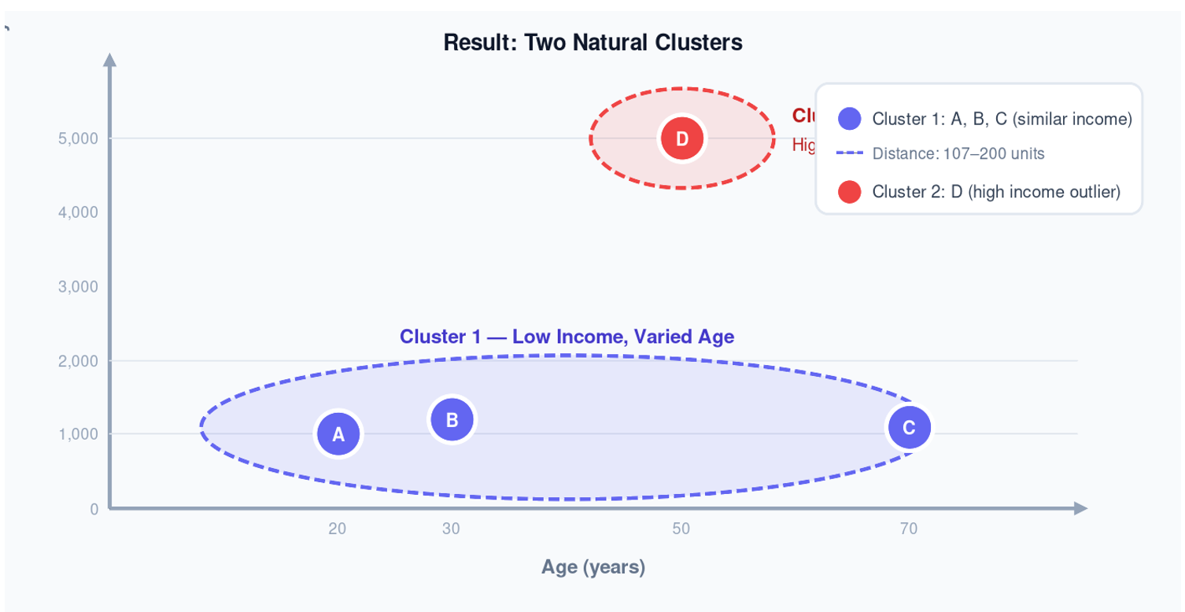

9. The Problem Feature Dominance
Did you notice something in the above calculations?
In our raw distance calculations, income completely dominated the result. This is because income values (1,000–5,000) are hundreds of times larger than age values (20–70). The age difference barely matters when calculating the distance!

The Solution: Min-Max Scaling
Before computing distances, always scale your data to bring all features onto the same 0–1 range. This gives every feature a fair contribution.

X_scaled = (X − X_min) / (X_max − X_min)
Min-Max Scaling Formula — brings every feature to the 0–1 range

Customer | Age (raw) | Age (scaled) | Income (raw) | Income (scaled)
A | 20 | 0.00 | 1,000 | 0.000
B | 30 | 0.20 | 1,200 | 0.050
C | 70 | 1.00 | 1,100 | 0.025
D | 50 | 0.60 | 5,000 | 1.000

Key Rule: Always scale your features using Min-Max Scaling (0–1) or Z-score Standardisation (mean=0, std=1) before computing distances. Without scaling, features with large numerical ranges unfairly dominate the clustering result.

We will deep dive in more detail on scaling in our future blogs.

10. Beyond Two Dimensions
We used Age and Income in this example so the data could be visualised on a 2D graph. In the real world, you will have 50, 100, or even 1,000 features per customer. Visualisation is no longer possible beyond 3 dimensions.

Key Insight: The mathematics of clustering is identical regardless of the number of features. The Euclidean formula simply extends to N dimensions: Distance = √[Σ(xi − yi)²]. Visualisation is for human intuition it is NOT a requirement for clustering to work.

Coming Next in the Series
This is just the starting! Here’s what’s lined up in the Machine Learning Simplified series:

- Distance Metrics Deep Dive Euclidean, Manhattan, Minkowski (intuition + maths)
- Similarity Measures Cosine Similarity, Jaccard Index and how they differ from distance
- K-Means Clustering How it actually works (intuition + maths)
- DBSCAN Density-based clustering explained
- How to Choose K The Elbow Method
- How to check Quality of the Clusters Silhouette
- Clustering in Python — End-to-end walkthrough

Your Feedback Matters! The goal of this series is to explain Machine Learning concepts in a simple, visual, and intuitive way. Feel free to share your thoughts, and I’ll do my best to incorporate them in future blogs.

